Supporting the Blue Economy - SECOORA Annual Meeting
Hyatt House Charleston/Historic District, 560 King Street, Charleston, SC 29403
May 22-24, 2018 | Website | Speaker Biography

Doug Piatkowski

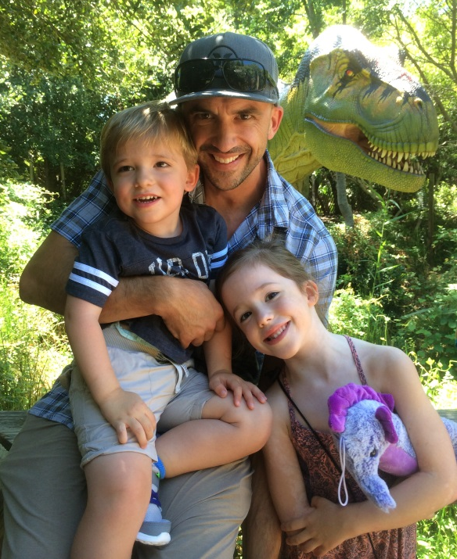
Doug Piatkowski graduated from the University of North Carolina at Wilmington with a Bachelor of Science degree in Marine Biology in 2000 and a Master of Science degree in Marine Biology in 2002. Mr. Piatkowski’s graduate research focused on the impacts of beach nourishment activities on the nest success of loggerhead sea turtles on Masonboro Island, NC. He spent 12 years working as a Marine Biologist at the US Army Corps of Engineers Wilmington District evaluating the environmental implications of dredging and beach placement activities. In 2013 Doug was hired by the Bureau of Ocean Energy Management as a Marine Biologist within the Marine Minerals Program providing environmental policy guidance, direction, and supervision for environmental assessment and consultation activities related to sand and gravel leasing decisions in the Outer Continental Shelf (OCS). Current responsibilities include evaluating impacts of OCS activities on the environment in accordance with environmental laws such as the National Environmental Policy Act, Magnuson Stephens Fishery Conservation and Management Act, Endangered Species Act, Marine Mammal Protection Act, etc. Mr. Piatkowski is also currently managing a portfolio of environmental studies funded by BOEM’s Environmental Studies Program to fill data gaps and adequately assess the impacts from marine mineral development.
Doug Piatkowski
BOEM’s Environmental Studies Program

