Firm: | Environmental Research Group, L.L.C.
Headquarters: | 6049 Falls Road, Baltimore, MD 21209 |  |  | www.envrg.com
POC: | Gina L. Foringer, President and CEO
Phone: | 410.366.5170 | Email: | gina.foringer@envrg.com
CAGE: | 1P0W9 | UEI: | GB15HGP1LW68
Business Size Status: Certified 8(a), Service-Disabled Veteran-Owned (SDVO,) Economically Disadvantaged Woman-Owned (EDWO,) and Small Business under NAICS 541620 (less than $16.5M) founded in 2000.
Primary NAICS Code: 541620 – Environmental Consulting Services under $16.5M

Environmental Research Group, LLC (ERG) has been providing contractor support services to the NOAA NESDIS and NMFS programs, U.S. Corps of Engineers (USACE) and Department of Defense (DoD) for our entire corporate history. This support includes natural and cultural resources management, environmental compliance, National Environmental Policy Act (NEPA) and stormwater support, restoration services, planning and conservation, pollution prevention, ecological restoration, occupational and environmental health studies and evaluations, audits and assessments, training, and record management. ERG’s staff have a long history of providing this type of environmental compliance support across the country.

Founded in 2000 and now with a current staff of over eighty-five (85) people, ERG is dedicated to providing environmental and cultural resource consulting services for both direct project support and on-site staff assistance needs. We are presently working in numerous states simultaneously, including Maryland, Virginia, North Carolina, South Carolina, Georgia and Florida, where we do NEPA work, Natural and Cultural Resources, Environmental Training and Audits, and Environmental Compliance work. We manage approximately 90 projects totaling $12M at any given time, both CONUS and OCUNUS.

The following list highlights a sample of the services and expertise we provide to our clients.

- Natural resources management & plans
- Ecological restoration
- Land management & master plans
- Biological inventories
- Threatened & endangered species surveys and consultation
- Wetland determinations & delineations
- Wildlife management
- Invasive species management
- NEPA & community involvement
- Prehistoric and historic terrestrial, and maritime archaeology
- Artifact analysis and curation
- Compliance audits
- Environmental cleanup and restoration
- Storm water management
- Training
- NAGPRA
- Archival services
- History, architectural history, HABS/HAER/HALS documentation
- Historic studies, preservation and planning, and conservation
- Geomorphology
- Geophysical surveys
- Heritage interpretation and public outreach

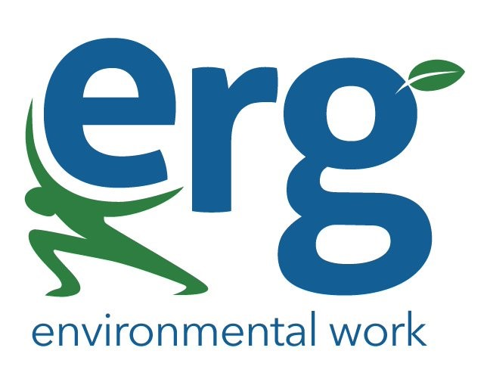

ERG – Trust * Expertise * Compassion

